**Bỏ màn chọn kho và màn chọn phiếu nhập xuất, thay màn chọn phiếu bằng màn scan mã phiếu, sau đó gọi API lấy thông tin ngày + kho để fill vào 2 trường bên dưới:**

**Mô tả chung Màn hình Scan lấy mã đơn:**

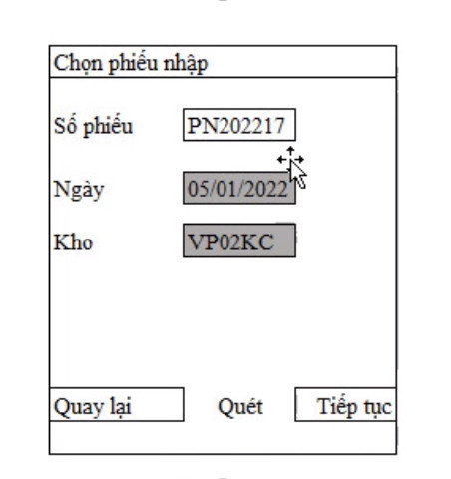

|  |  |  |
| --- | --- | --- |
| **Fiels** | **Nhập** | **Xuất** |
| Số phiếu | PurchaseOrderNo | SaleOrderNo |
| Ngày | PurchaseOrderDate | SaleOrderDate |
| Kho | WarehouseCode | WarehouseCode |

**MÀN HÌNH NHẬP KHO**

- API: api-ht/saleorders/getsaleorderscan

- input:

{

  "BarcodeScan": "1234567876"

}

- outPut:

{

    "Message": "Lấy dữ liệu thành công",

    "RespondCode": **null**,

    "ErrorCode": "0",

    "data": [

        {

            "ID": 7,

            "PurchaseOrderNo": "167890875577",

            "PurchaseOrderDate": "2022-01-01T00:00:00",

            "WarehouseCode": "KAMIS1",

            "WarehouseName": "Hà nội",

            "ExportStatus": "N",

            "InputStatus": "1",

            "PrintStatus": "N",

            "GetDataStatus": "N",

            "RecordStatus": "N",

            "CreateDate": "2022-01-01T00:00:00",

            "UserCreate": "giangapao1",

            "UserUpdate": **null**,

            "UpdateDate": **null**

        }

    ]

}

**MÀN HÌNH XUẤT KHO**

- API: api-ht/purchaseorder/getpurchaseorderscan

- input:

{

  "BarcodeScan": "1234567876"

}

- output xuất:

{

    "Message": "Lấy dữ liệu thành công",

    "RespondCode": **null**,

    "ErrorCode": "0",

    "data": [

        {

            "ID": 1,

            "SaleOrderAmisID": 1,

            "SaleOrderNo": "1234567876",

            "CustomerCode": "1",

            "CustomerName": "1",

            "SaleOrderDate": "2022-01-10T00:00:00",

            "WarehouseCode": "KAMIS1",

            "WarehouseName": "Hà nội",

            "ExportStatus": "N",

            "GetDataStatus": "N",

            "RecordStatus": "N",

            "CreateDate": "2022-01-10T00:00:00",

            "UserCreate": "1",

            "UserUpdate": **null**,

            "UpdateDate": **null**

        }

    ]

}

Data: theo model cũ của màn nhập xuất.